Part A – Theory
1. Define UI and UX with real-life examples:
Answer: UI (User Interface) is the look of a product. It includes what user see and touch such as buttons, icons, colors, text and screen layout.
There are many real-life UI examples like mobile phone home screen , online shopping website etc.
An online shopping website is considered a real life UI example because user can interact with buttons , menu , images to buy product easily. Online shopping website shows UI through its layout and design. It includes product image, menu, search bar and buttons. Clear font helps user to find product quickly and shop easily. So UI makes a website simple, attractive and easy to use .
UX (User Experience) is about how user feels when interacting with product , website and application. It focuses on how easy, smooth and enjoyable the system is to use. UX design helps user find information quickly , complete the task without any confusion and feel satisfied.
There are many real-life UX examples like ATM , food delivery app, online website etc.
Mobile banking app is also considered as real-life UX example because good UX allows user to log in easily. Check their account balance, transfer money and pay bills without confusion. when users can complete task smoothly and feel confident whole using the app , it shows good user experience.
2. Differentiate between Font & Typeface with at least two examples each.
Answer: Font and Typeface are commonly used terms but they have different meaning and uses.
1) Font is a specific version of typeface. It includes the size , weight and style . Example: Arial is typeface but Arial bold , size 12 is Font and Time New Roman Italic , size 14
Typeface is a style or design of letter. It helps to understand how the text looks on the page or screen . example: Arial , Calibri etc.
2)Fonts are used to apply specific text styles for headings to make them stand out from normal text. example of heading : The story of Winter Season
Typefaces are used to define the general look of text in books , website and application . Example : Once upon a time there was a tiger or One winter morning , snow fell softly from the sky .
3. Explain Colour Psychology. Suggest a colour palette for:
O A healthcare website
o A gaming app
Answer: Colour psychology is the study of how colours affect human emotions, feelings and behavior. Colours help attract user attention and convey meaning. Designers select colours that match the purpose of the website or application and creat the right emotions in users. Different colours create different feelings such as trust, excitement or calmness. UI/UX designers choose colours carefully to attract attention, improve readability and guide user through interface.
A colour palette for a healthcare website: A healthcare website must create a sense of trust , safety , cleanliness , calmness. A healthcare website colour palette should be soothing , professional , readable and accessible. According to me , a healthcare website colour should be green , blue and red .Green symbolizes health, healing, nature and recovery . we can use green as a primary colour . Blue symbolizes trust , reliability mostly. We can use this colour in “Book Appointment” button to build user confidence. Red indicates alert , urgency . In healthcare design red can be use as plus (+) sign.
A gaming app must create a feeling of excitement, energy. In gaming app use bold, high contrast and vibrant colours to create dynamic experience. According to me, in a gaming app we can use a dark background like black or blue to make the users feel more involved and deeply focused in the game . we can use red or orange colour to highlight action buttons and urgent game events. Green can use for rewards and success indicators. In gaming app for text we can use white to ensure clear readability.
4. Describe the sections of a website (header, main body, footer). Why is structure important?
Answer: A website is divided into different section to arrange information properly. The main sections are header, main body and footer .
Header is the top section of a website that contains the logo , site name , navigation bar (navigation menu are home, about us, services, blog, contact us). It helps users identify the website. As example, on Amazon website the header has the logo, search bar, account info, cart icon.
Main body is the central section of the website where main information is displayed. It includes text, images, product listing, blogs, video . this is the focus area where users interact most. As example, on Amazon the main body shows product categories, featured products and product listing.
Footer is the bottom section of a website. It contains contact info, additional link, social media link, privacy policy and FAQs. As example, on Amazon the footer has help links, policies and social media icons.
This structure is important because it helps users easily understand and navigate the website. It keeps information organized. A clear structure makes the website look professional and easy to use.
Part B – Practical
1. Create a simple low fidelity wireframe for a school website homepage (using boxes for
structure).
Answer:
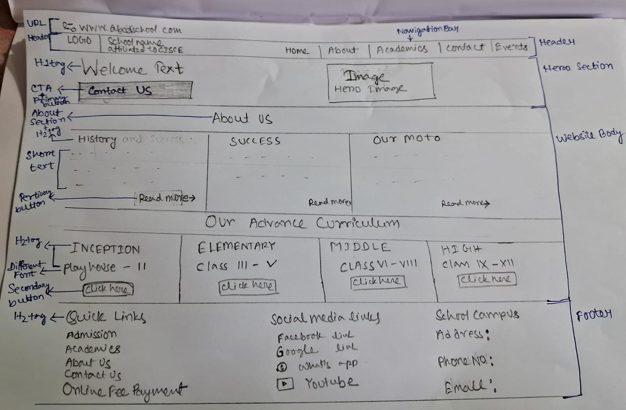

2. Take an existing website screenshot and label all its sections.
Answer:
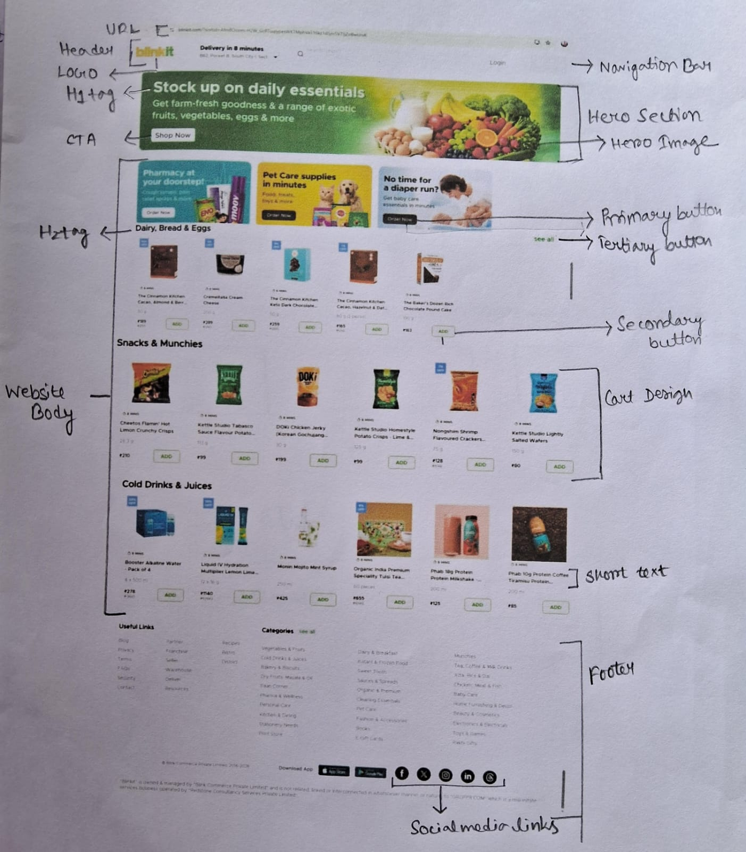

3. Suggest 2 font combinations suitable for:
O Corporate website
O Kids’ app
Answer: Fonts help make a design look good and easy to read. The right fonts match the project’s purpose. Corporate websites need fonts that are professional while kids apps need fonts that are fun and friendly.
Corporate website:
Goal: Professional, clean, easy to read
Font combination 1:
Header: Cambria , example: WELCOME TO OUR COMPANY
Body : Arial , example: We provide professional services for your business.
Font combination 2:
Header: Georgia
Body : Times New Roman
Kids’ App:
Goal: Fun, playful, easy to learn for children
Font combination 1:
Header: Comic Sans MS , example: LET’S PLAY TOGETHER
Body : Verdana, example : Tap the stars to start the game.
Font combination 2:
Header: Cooper Black
Body: Arial Rounded MT Bold
Part C – Critical Thinking
1. How would you design a website to make it accessible for colour-blind users?
Answer: A website should be easy to use for everyone, even people who are colour blind. We need to follow some design steps or tips. To Make a website accessible, designer can use high contrast between text and background and avoid using only colour to show important information means we need to add labels, icons , symbols and make buttons, links clear with underline. Pick colour blind friendly colours like blue and orange. Use readable fonts and provide text description for images, charts or colour coded content. Finally test the website with colour blind checker to ensure it works. This makes the website easy and clear for all.
2. Compare the UX of Amazon vs. Flipkart(or similar apps). What differences do you notice?
Answer: Amazon and Flipkart are popular e-commerce websites. Their UX (User Experience) affects how easy and comfortable to search , buy the products. They have some differences also like :
(a) Amazon has clean and simple design, easy to navigate but Flipkart is colourful and busy, showing many offers .
(b) Amazon gives clear product suggestions but Flipkart focuses on deals and discount.
(c) Searching on Amazon is fast and precise but Flipkart’s search works well but looks crowded.
(d) Product pages on Amazon are consistent whereas Flipkart sometimes change layout.
So both apps have easy checkout but Amazon feels smoother. Overall Amazon is user friendly and Flipkart is promotion focused.

